**Private Mortgage Insurance (PMI) explained**

What is mortgage insurance?

**[Keith Gumbinger](https://www.hsh.com/press-room/author/keith-gumbinger.html)**    HSH.com

Whether it's called “private mortgage insurance” (PMI) or just plain “mortgage insurance” (MI), mortgage insurance is an insurance policy which protects the lender in the event that you, the borrower, fail to make your mortgage payments. You pay for a policy as an inducement for the lender to offer you financing.

Don't confuse PMI with credit life insurance. Mortgage insurance won't pay your mortgage each month should you become disabled, unemployed or deceased, and pays nothing to you or any of your beneficiaries.

Almost all borrowers who have less than a 20 percent down payment or equity stake will be required to have an MI policy in place as a condition of funding their mortgage.

**Superior Credit (760+)**

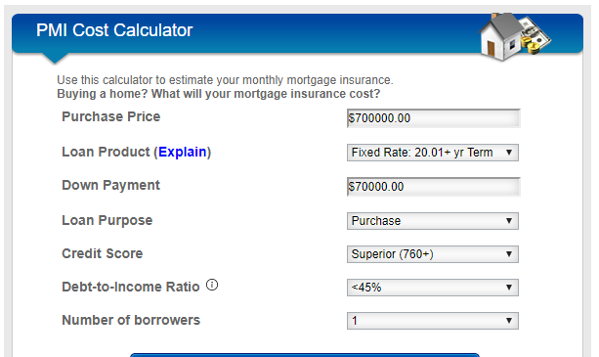

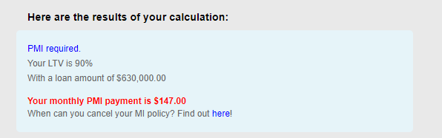

**Fair Credit – (700-719)**

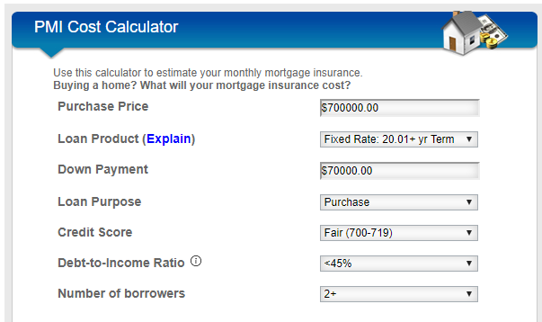

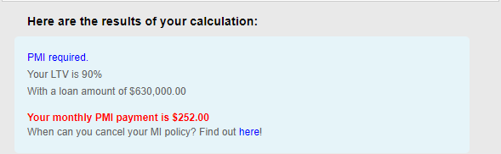

**Mediocre Credit (680-699)**

